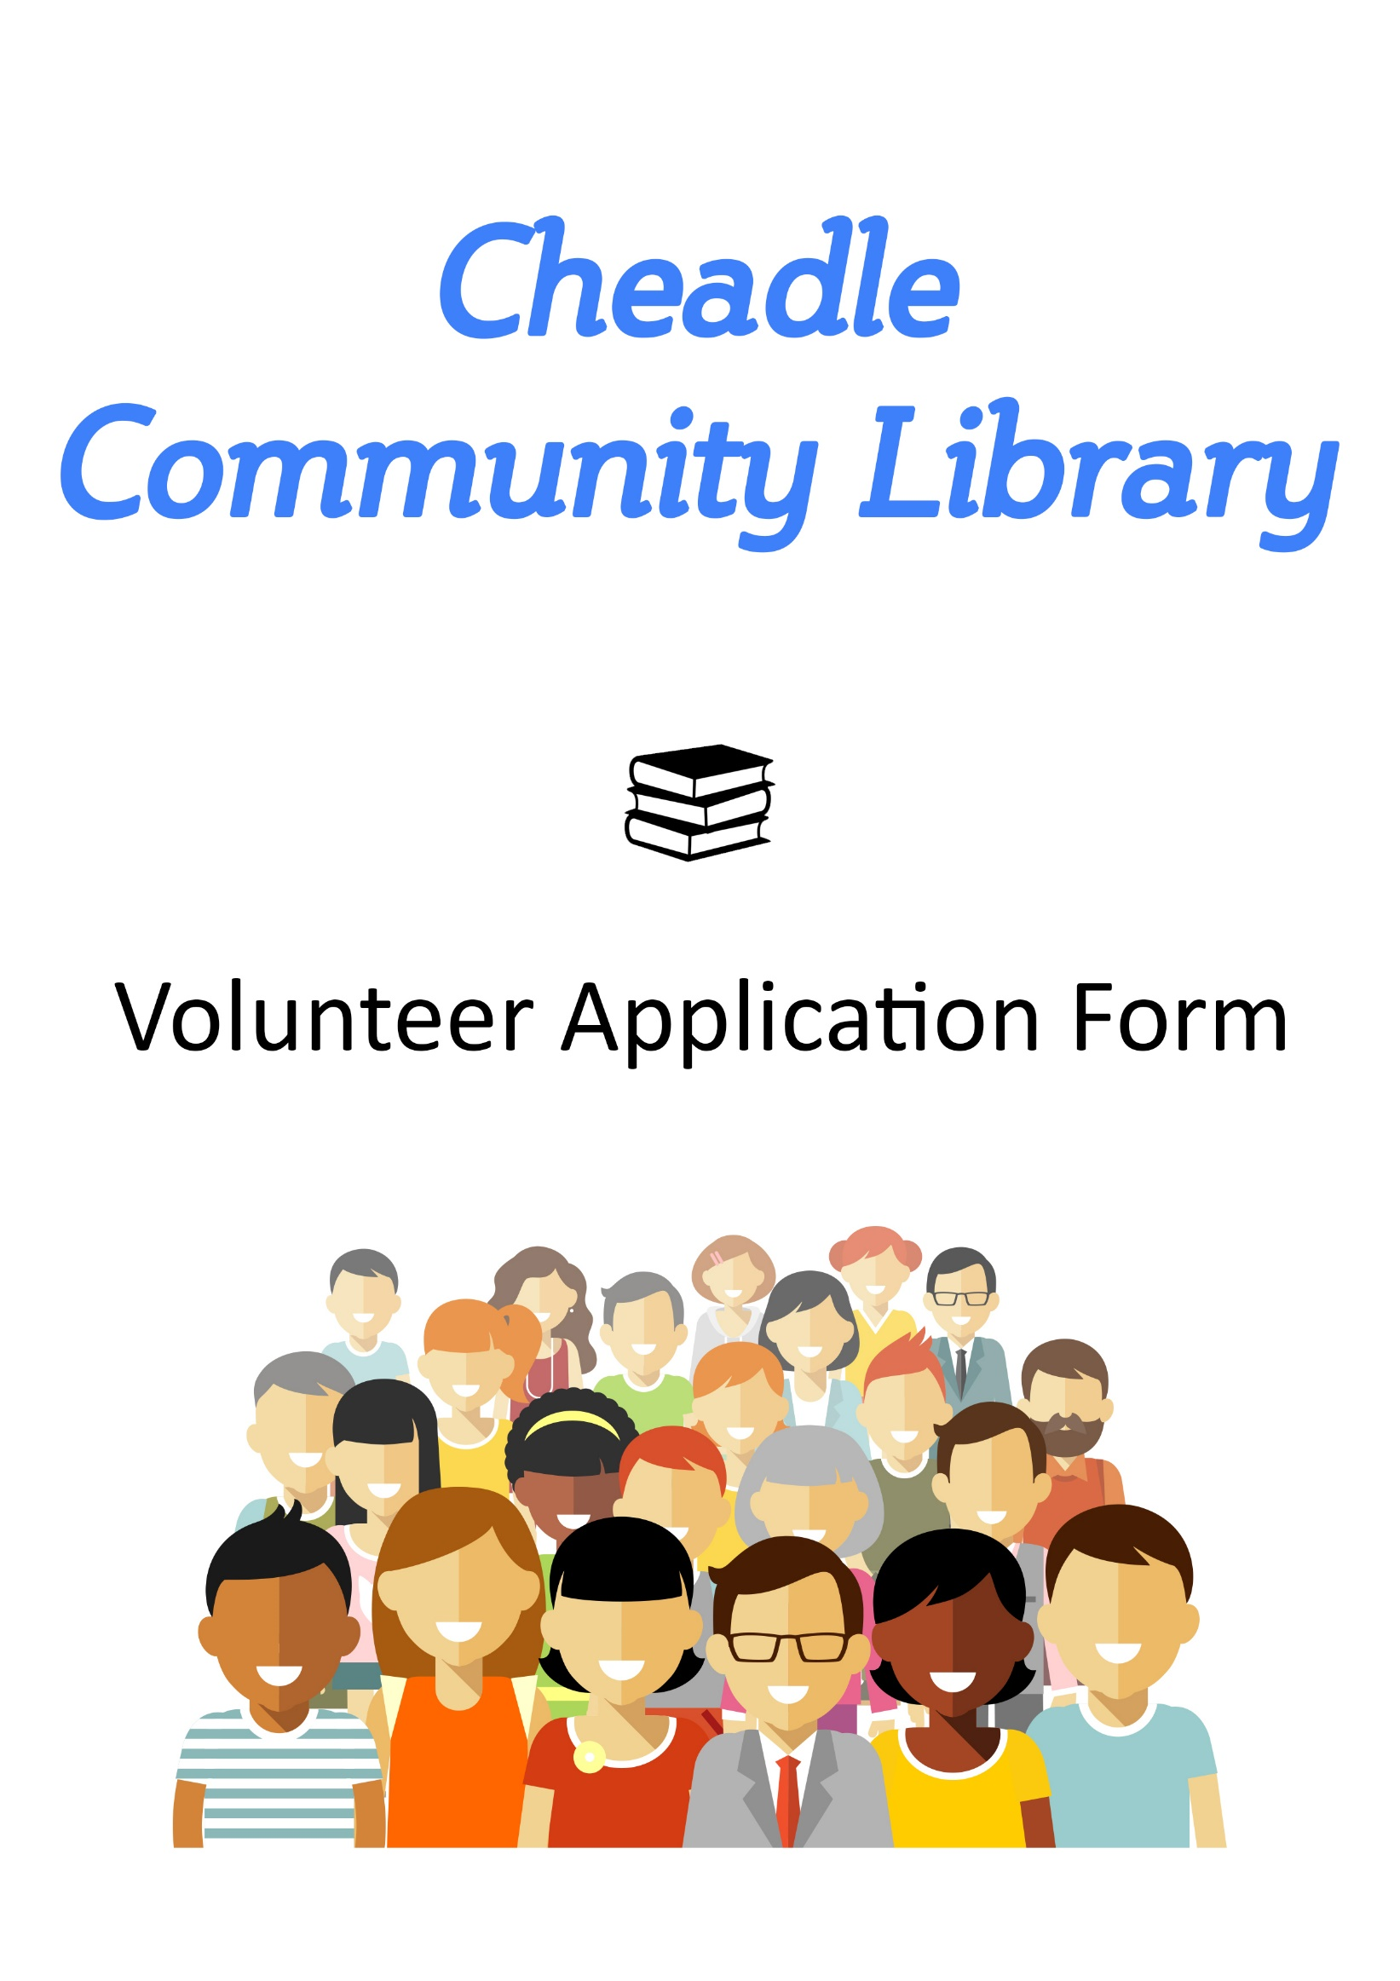
Cheadle Community Library
Application to Volunteer

Full Name:

Address:

Mobile No:

Landline No:

Email Address:

Which role are you interested in?

Tell us about any volunteering or work experience you have done

Do you have any specialist skills or interests that you would be able to use when volunteering?

Why would you like to volunteer in Cheadle Community Library?

Please give details of any experience, special knowledge, skills, personal qualities relevant to volunteering at Cheadle Library, you feel you could use

When are you available to volunteer?
 | Monday | Tuesday | Wednesday | Thursday | Friday | Saturday
9am – 1pm

1pm – 5pm |  |  |  |  |  | CLOSED

Please provide details of two referees who can comment on your suitability for this role? These can be character references but must not be your relatives.
Referee 1  Full Name: | Referee 2  Full Name:
Address: | Address:
Tel No: | Tel No:
Email Address: | Email Address:

Do you have any special requirements that we can help you with in order to make the application process easier for you?

Privacy Notice

Cheadle Library is a community managed library and collects and holds information you provide for purposes connected with your voluntary service, including this application form. The sort of information we will hold will relate to your voluntary activities. It may include information for expenses, references, contact names and addresses, training and may include some health details and information about the activities you have undertaken and where. The purpose of which is to manage your role as a volunteer.

We may also keep information about your health for the purposes of; compliance with our health and safety obligations; or considering how your health affects your ability to do volunteer activities and, if you are disabled, any adjustments we need to make to assist you.

If you need to know what information is kept about you, then we will tell you and explain why it is kept.

The information we hold will be for management and administrative use only.

We will retain this information throughout your time volunteering with us. If you choose to finish volunteering, your information will be kept for 18 months and then confidentially destroyed.

Your name and address details together with your email address will be passed to Staffordshire County Council in order for them to issue to you your library computer log on permissions.

Your details will be kept in accordance with the General Data Protection Regulations (GDPR). They will be held securely and confidentially. They will be accessed by authorised personnel only.

I declare the information I have provided on this application form is true.

Signed: Date:

